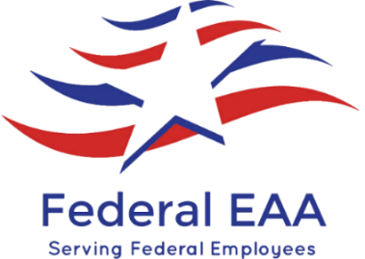
7500 Security Boulevard
Baltimore, MD 21244
410-786-3655
Questions? federaleaa@gmail.com
THANK YOU FOR SUPPORTING YOUR EAA (EMPLOYEES ACTIVITIES ASSOCIATION)
OUR SERVICES INCLUDE:
EAA/CMS Fitness Center
United States Post Office (Full Service)
Gift Cards & Gift Card Holders
Gift Bags
Greeting Cards
Online Shopping with Payroll Deduction: PURCHASING POWER, CORPORATE JEWELERS,
SOLENVE, LUTHER SALES, VACATION WISER, SNOOPDRIVE
Insurance Services with Payroll Deduction: SHORT TERM DISABILITY PLAN,
ACCIDENT PLAN, CANCER CARE PLAN, HOSPITAL CHOICE PLAN, PERMANENT IINDIVIDUAL
LIFE INSURANCE FOR FAMILY & MEMBER
Legal Shield with Payroll Deduction
Helium Balloons (Birthday, Get Well, Congratulations, Thank You, New Baby & More)
Umbrella Sales
Notary Public (FREE! We do ask that you donate to our charity of the month)
DISCOUNTED TICKETS/SPECIAL OFFERS
Ticketsatwork.com Company Code FEAA: Discounts on Disney, Shows, Hotels, Concerts
Movies, Theme Parks, Rental Cars, Sporting Events & Much More……..
Simply visit www.ticketsatwork.com enter your email address &
Use Company Code FEAA to receive special discounts
We donate to charities each month. Charities are listed in our monthly newsletter
which is available on our website.
Visit our website www.federaleaa.org to sign up to receive our monthly newsletter.

